|  |  |  |  |  |
| --- | --- | --- | --- | --- |
| Class |  | International |  | ACC |
|  |  |  |  |  |
| Name | 1 | Pratama Aji Nur Rahman | D400154003 |
|  | 2 | Amnaduny Akhara | D400154006 |
|  | 3 | Milzam Wafi Azhar | D400154007 | ACC Date : |
|  | 4 | Jeski Saputra | D400154009 | Revise Date : |

MODULE 3

DISTANCE INDICATOR WITH BUZZER USING ARDUINO MICROCONTROLLER

1. PURPOSE
2. To know operating system in Arduino using FreeRTOS
3. To know the use of Flexible and Timing ON in FreeRTOS
4. TOOLS AND EQUIPMENT
5. Laptop
6. PCB (Project Board)
7. Arduino Nano
8. Relay 5V Single Channel
9. Sensor Ultrasonic
10. Buzzer
11. Jumper Cable
12. RESULT OF PROJECT

C.1 Circuit Design

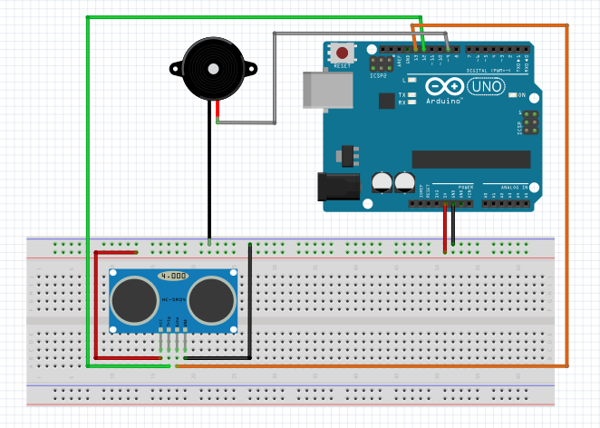

C.2 Picture of Design

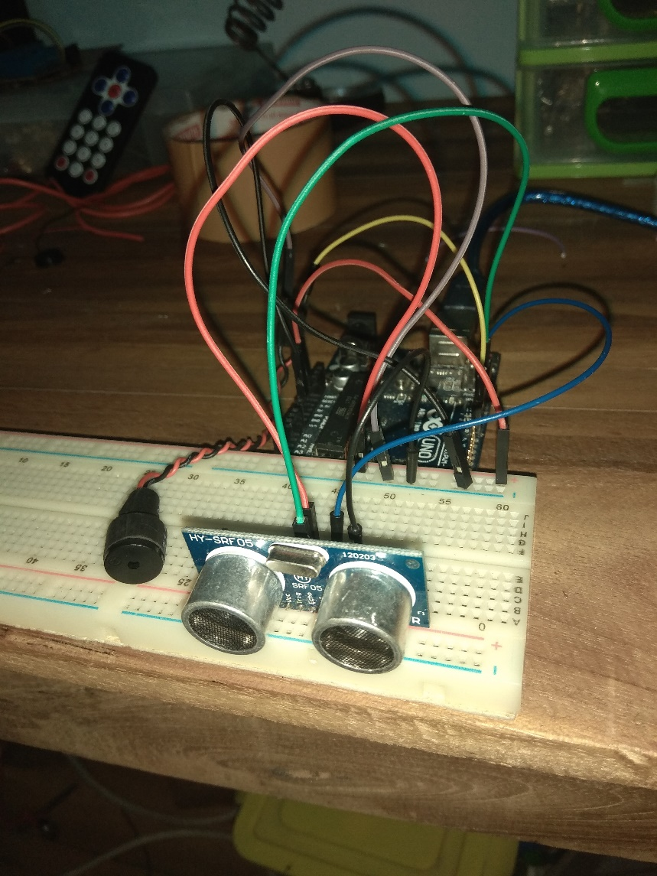

C.3 Script Program

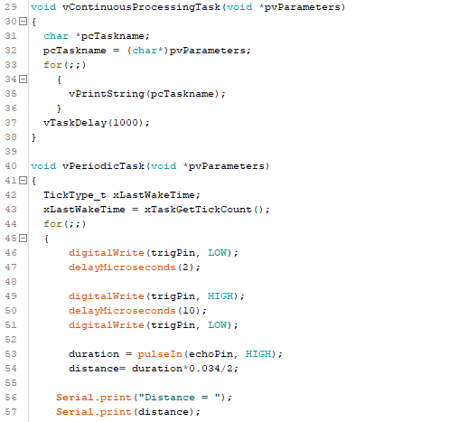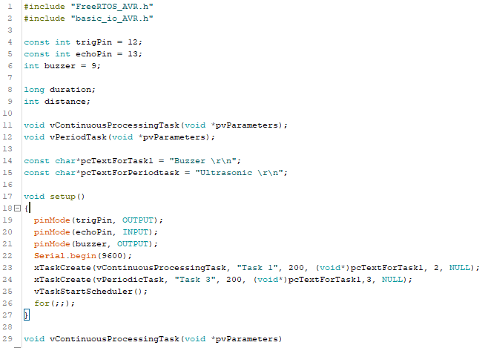

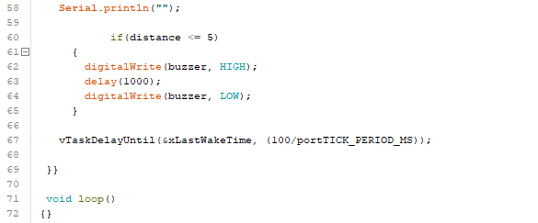

C.4 Picture of Result



1. ANALYSIS

In this project used ultrasonic as a primari sensor for the system. And for the buzzer used as an indicator by the trigger of ultrasonic distance measurement process. In the script for the project has higher priority in ultrasonic sensor and for the buzzer is only waiting for the triggering by sensor. This project still uses which component should be done by higher priority and calling parameter pointer.

The working principle is when the sensor is operating and it measures less than 5 cm then the buzzer will turn ON for 1 second and then off.

1. CONCLUSION
2. For the 1st priority is sensor Ultrasonic and 2nd priority is the indicator buzzer because the main system is measuring system so the sensor is the 1st priority
3. The higher priority must be the sensor.